**Assignment Exercise for PHP: Built in function**

1. **How to get array first element without knowing the key of Array using PHP built-in function only?**

**Answer 1:**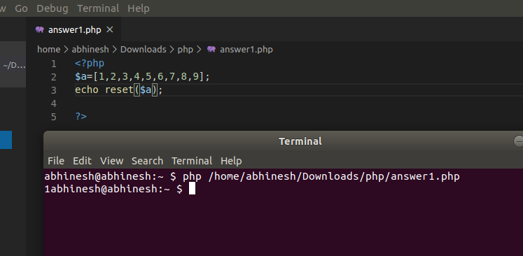

1. **How can we get the second of the current time using date built-in functions?**

**Answer 2:**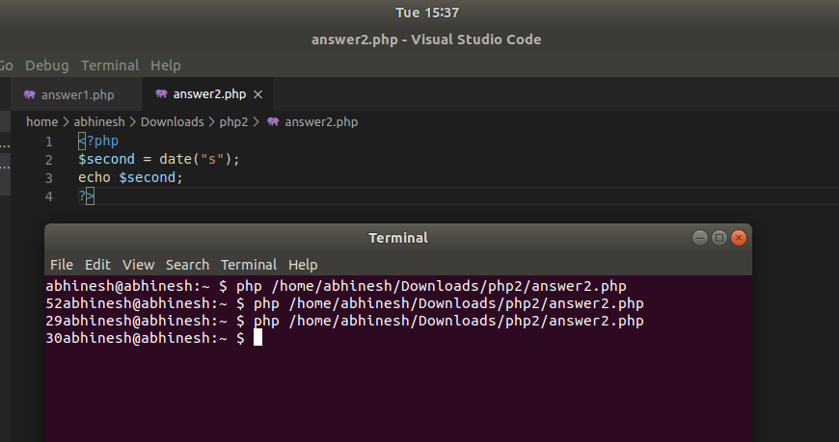

1. **What is the difference between the functions unlink and unset?**

**Answer 3:**In PHP unlink() is a function for file system handling, unlink() is used to delete files. Suppose you have uploaded a file and wants to delete this file through the coding then unlink() function is used to delete the file.

unset() is a function for variable management. It will make a variable undefined. Or we can say that unset() is used to null out the value of a given variable. OR Unset () is used to destroy a variable in PHP. In can be used to remove a single variable, multiple variables, or an element from an array.

**Question 4: How to append data into a file named 'abc.txt'?**

**Answer 4:**

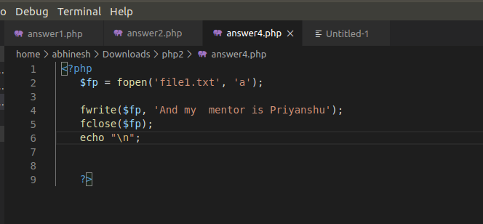

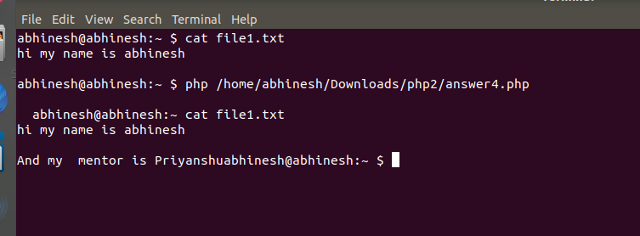

**Question 5 :How can we get the properties (size, type, width, height) of an image using PHP built-in functions?**

**Answer 5:**

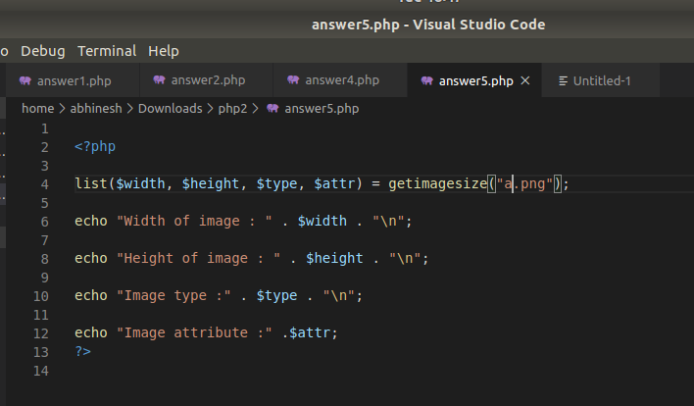

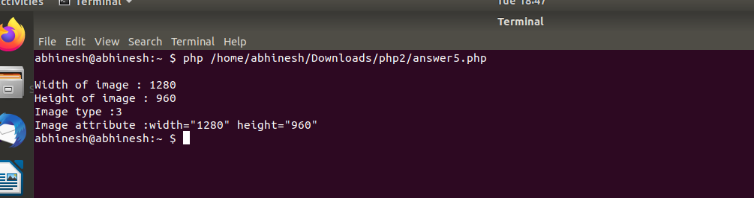

**Question : 6Write a program to check if a string is a PALINDROME or not using built-in functions?**

**Answer 6:**

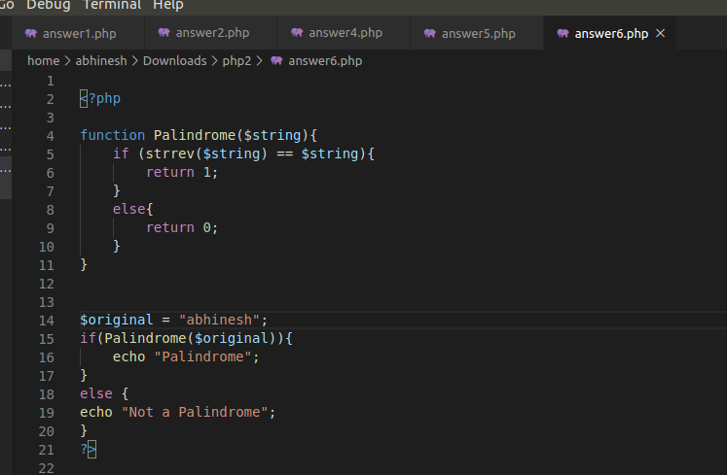

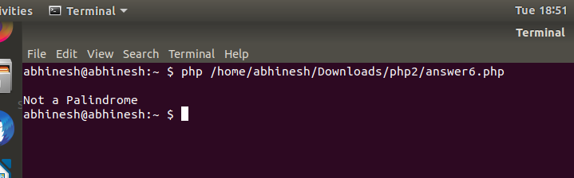

**Question 7:How to pass variables by value and reference in PHP? Explain with code snippets.**

**Answer 7:**By default, function arguments are passed by value (so that if the value of the argument within the function is changed, it does not get changed outside of the function). To allow a function to modify its arguments, they must be passed by reference.To have an argument to a function always passed by reference, prepend an ampers and (**&**) to the argument name in the function definition.

**Call by value:**

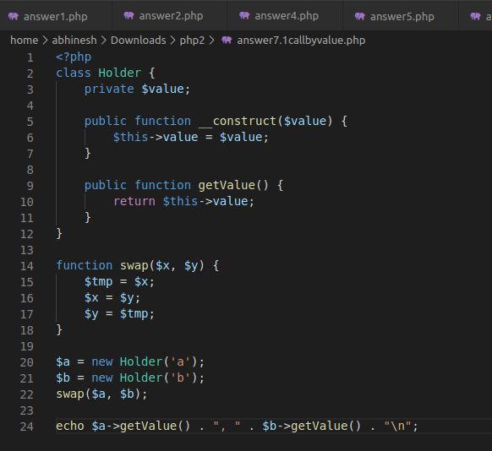

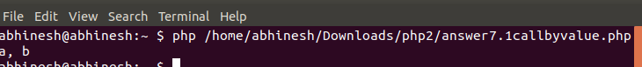

**Call by reference:**

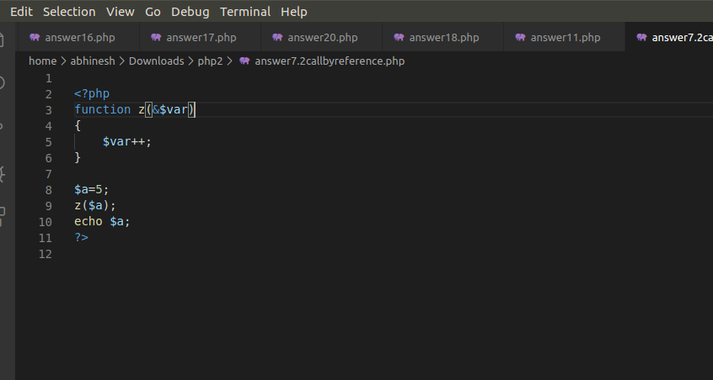

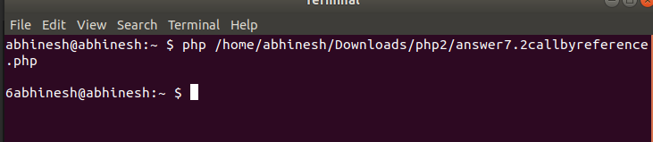

**Question 8:What’s the difference between the include() and require() functions? Show with an example.**

**Answer 8:**The difference between include and require arises when the file being included cannot be found: include will emit a warning (E_WARNING) and the script will continue, whereas require will emit a fatal error (E_COMPILE_ERROR) and halt the script. If the file being included is critical to the rest of the script running correctly then you need to use require.

**Example of Include :**

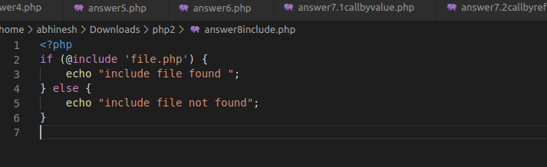

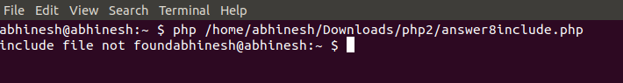

**Example of require:**

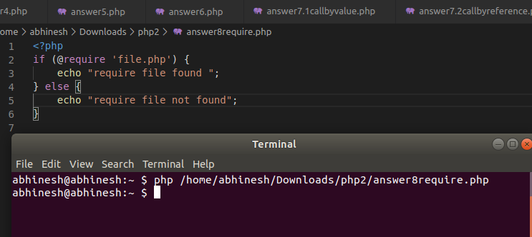

**Question 9:Explain different sorting function in PHP? Show with Examples.**

**Answer 9:**

1. sort() - sort arrays in ascending order
2. rsort() - sort arrays in descending order
3. asort()- sort associative arrays in ascending order, according to the value
4. ksort()- sort associative arrays in ascending order, according to the key
5. arsort()- sort associative arrays in descending order, according to the value
6. krsort()- sort associative arrays in descending order, according to the key

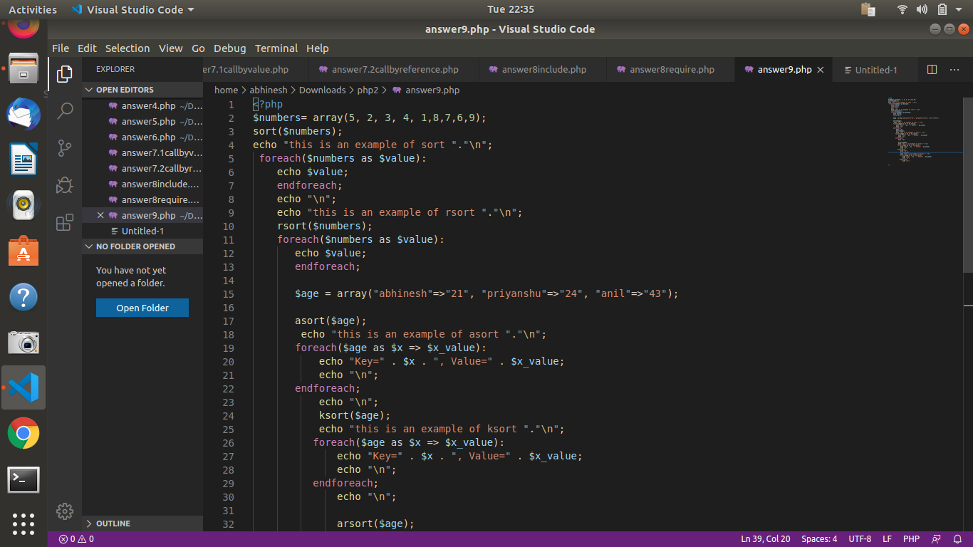

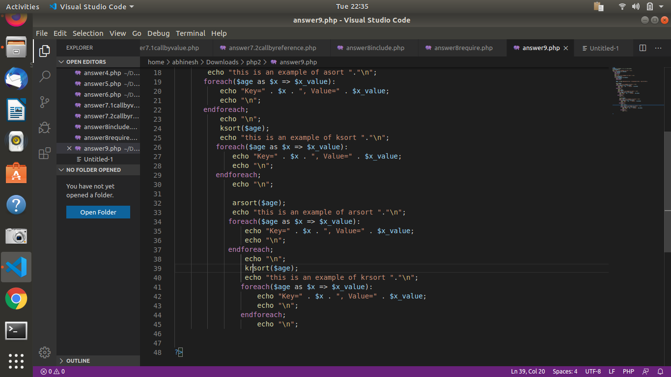

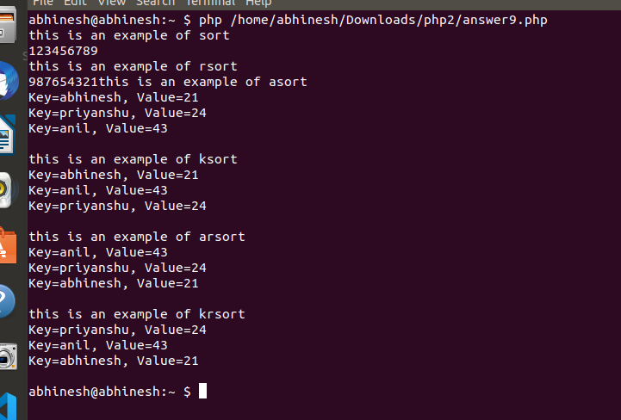

**Question 10:Differences between printf, print, echo, sprintf,vprintf, vfprintf, vsprintf in PHP?**

**Answer 10:**

***print* :**

* Output a string onto the screen – Also “print” is not a real function so you are welcome to remove the parentheses.
* Because this is a language construct and not a function, it cannot be called using variable function.
* **Always returns a 1**

***echo :***

* Output one or more strings
* Also not a real function but a language construct
* **Does not returns anything** so its cannot behave as a function.

***printf :***

* Output a formatted string
* Returns the length of the outputted string

***sprintf:***

* Returns a formatted string
* **Returns a string produced according** to the formatting string *format*

***vprintf:***

* Returns a formatted string
* Operates as printf() but accepts an array of arguments, rather than a variable number of arguments.
* Display **array values as a formatted string** according to *format*

***vsprintf:***

* Display **array values as a formatted string** according to *format*
* Operates as sprintf() but accepts **an array of arguments**, rather than a variable number of argument

***vfprintf :***

* Write a formatted string to a stream
* Write a string produced according to *format* to the stream resource specified by handle
* Returns the length of the outputted string

**Question 11 :**

**Find Time Difference between two dates   
 '2012-11-04 05:04:00' => Timezone = GMT  
 '2012-11-05 10:44:00' => Timezone = IST  
And Return Date Time in GMT format.**

**Answer 11:**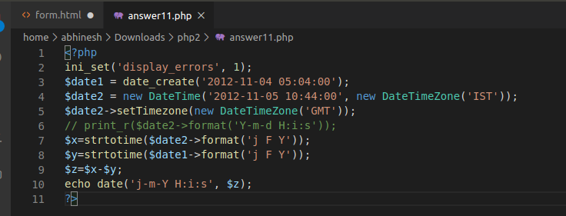

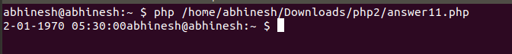

**Question 12 : Return contents of your working directory in descending order by name in PHP**

**Answer12:**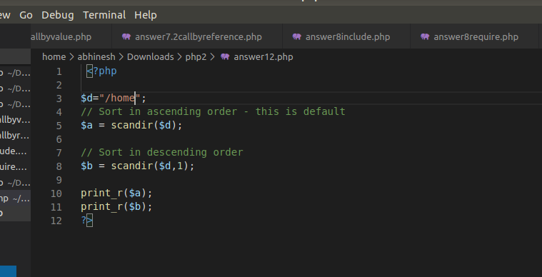

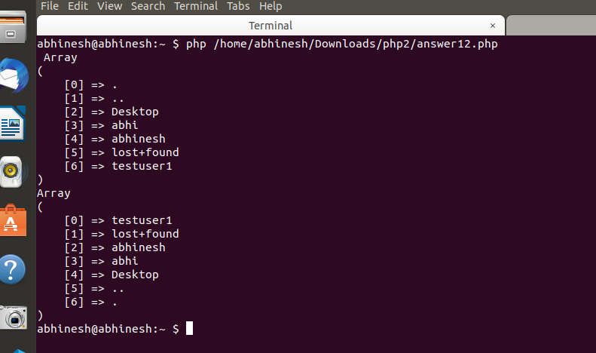

**Question 13: Write a Code using your knowledge of builtin functions to convert Sample string to Resultant String.  
 Sample string: '082307'  
 Resultant String: ‘08:23:07’**

**Answer 13:**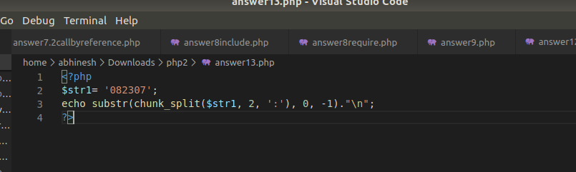

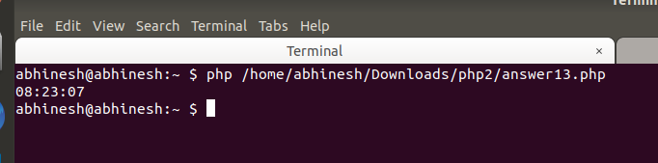

**Question 14 :Write code to extract the file name from the following string.  
 Sample String: 'www.example.com/public_html/index.php?q=123'  
 Expected output: ‘index.php’  
 Using Built-In Functions only!**

**Answer 14:**

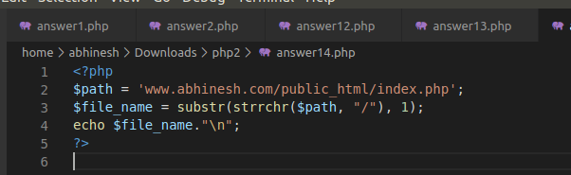

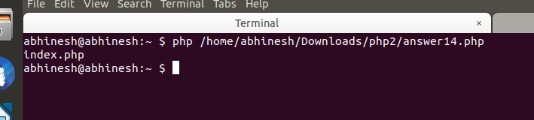

**Question 15 : Write a PHP script to extract the user name from the following email ID.  
 Sample String: 'rayy@example.com'  
 Using Built-In Functions only!**

**Answer15 :**

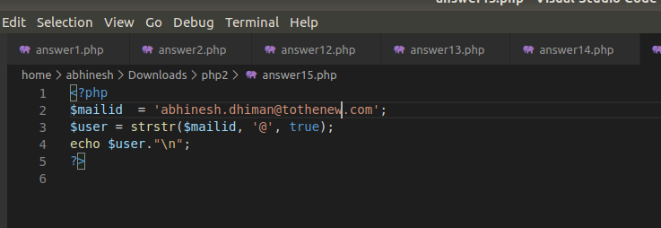

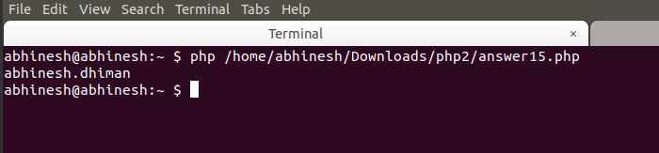

**Question 16 : Generate Random Password of 7 characters form this string '1234567890ABCDEFGHIJKLMNOPQRSTUVWXYZabcefghijklmnopqrstuvwxyz';  
 Note: Don’t use the rand() function. Check other built-in functions to get the result.**

**Answer 16:**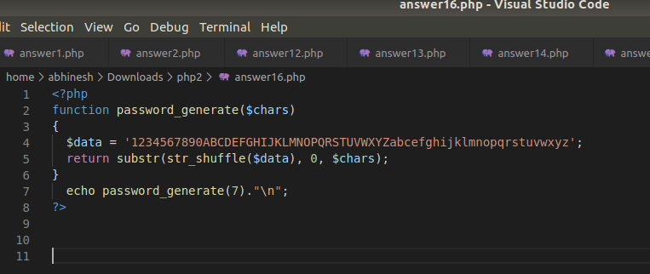



**Question 17: Write a Code to insert a string at the specified position in a given string.  
 String: 'The brown fox'  
 Insert 'quick' between 'The' and 'brown'.  
 Using Built-In Functions Only**

**Answer 17:**

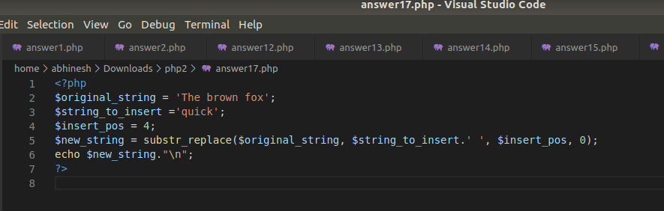

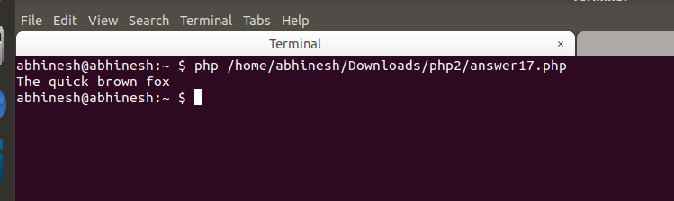

**Question 18 : Write a program in PHP which performs the same function as built-in function array_count_values**

**Answer 18:**

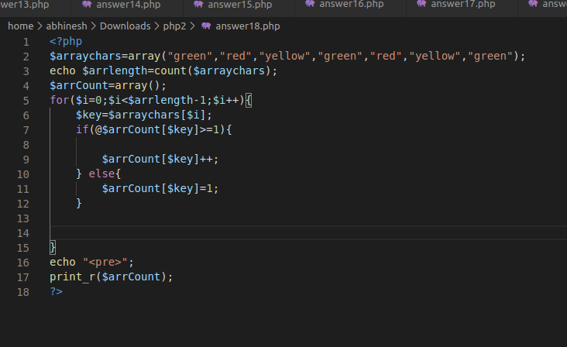

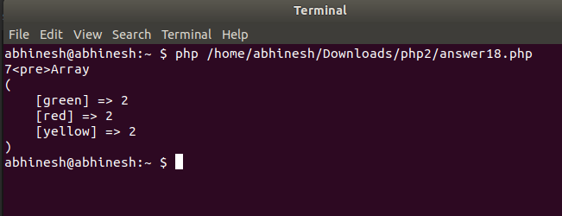

**Question 19 What is the use of sessions and cookies in PHP? How to set a session and a cookie with a code snippet.**

**Answer 19:**PHP has several powerful functions to allow it to remember individual users. These can be divided into two main categories, session handling and cookie handling.

A cookie is a small text file stored by the browser when it visits a web page. When the website asks for the cookie the browser sends it's contents - enabling the webserver to remember who the user is. Cookies can be set for any period needed, and will not be sent back after they have expired.

A session is a facility of PHP that prevents you from directly dealing with cookies. The server generates a random code, and sends this to the browser as a cookie. Data is then stored on the server in a special variable. When the user moves to another page, it sends the cookie to the webserver, which then gives PHP all the data '*specific to that user* that has been stored. Sessions only last for as long as the browser window is open.

**Question 20 : What is the output of this question ?  
 <?php  
 $a = array_fill(5, 6, 'banana');  
 $b = array_fill(-2, 4, 'pear');  
 print_r($a);  
 print_r($b);  
 ?>**

**Answer 20:** 